**Evidence_02 MS Excel**

1) Create the worksheet below in Microsoft Excel and save it as Marks:

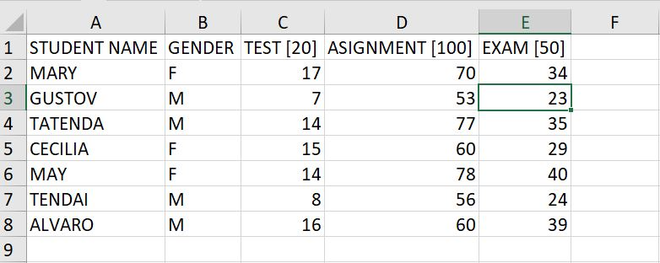

2) Insert a new column between column D and column E

3) In cell E1 enter the text “Course work”

4) In cell E2 enter a formula to calculate the coursework for the student.

**NB. Remember the Test is out of 20, the Assignment out of 100 and the Exam out of 50. The coursework mark contributes 40% of the final mark and the Test and Assignment carry equal weighting**

Copy the formula to the cells E3 to E8

5) In cell G1 enter the text “Final Mark”

6) In cell G2 enter a formula to calculate the final mark for each student.

**NB. The Exam mark contributes 60% of the final mark**

7) Sort the students in alphabetic order

8) Insert a new row with the cell pointer in cell A1

9) Merge the cells A1 to H1

10) In cell A1 enter the text “FCF MARKS”

11) Bold, underline, center, change font size of heading to 15 and the font to forte.

12) In cell H2 enter the text “Grade”

13) In cell H3 enter a formula for grading the student according to the final mark:

**The grading is as follows: 0-49=F, 50-64=C, 65-79=B, 80-100=A**

14) Filter all the students who got a test marks greater than 15. The list of students should be placed in cell range starting from cell A12

1. CREATE THE FOLLOWING FORM IN MS WORD

